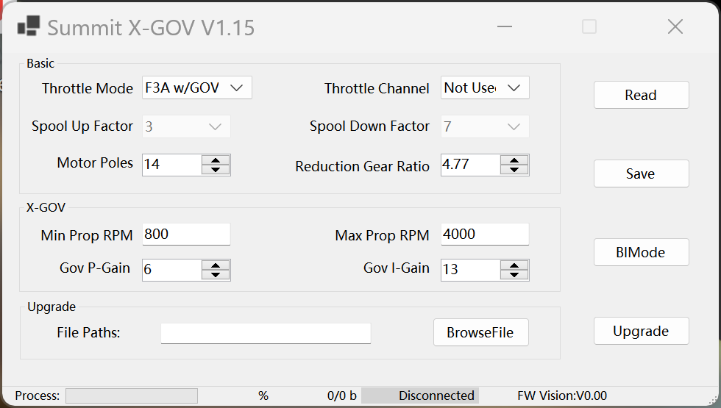

* Throttle Mode F3A w/GOV
* Throttle Channel Not Used (Read the throttle data from the bus when the PWM throttle channel is not connected;)
* Spool Up Factor 3 (default)
* Spool Down Factor 7 (default)

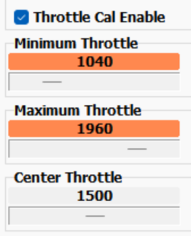Before the first time you use GOV mode, reset the transmitter throttle range and perform throttle channel calibration (only once)



Caution: Please perform throttle channel calibration in F3A/IMAC mode instead of GOV mode (which can be dangerous).

**The following parameters are for the CRS3000 MKII/MKIII & CRS3500 MKIII(AE)**

* Motor Timing 16 degrees (default for 100XHV)
* ESC Frequency 24KHz and up (default)
* Motor Poles 14
* Reduction Gear Ratio 4.77
* Min Prop RPM 800
* Max Prop RPM 4000
* Gov P-Gain 6 of 20
* Gov I-Gain 13 of 20

**Below: See GOV in action with Jeti's Log feature, which helps to optimize Gain P&I values**

